RICHMOND COUNTY PUBLIC LIBRARY

LONG RANGE PLAN 2021-2026

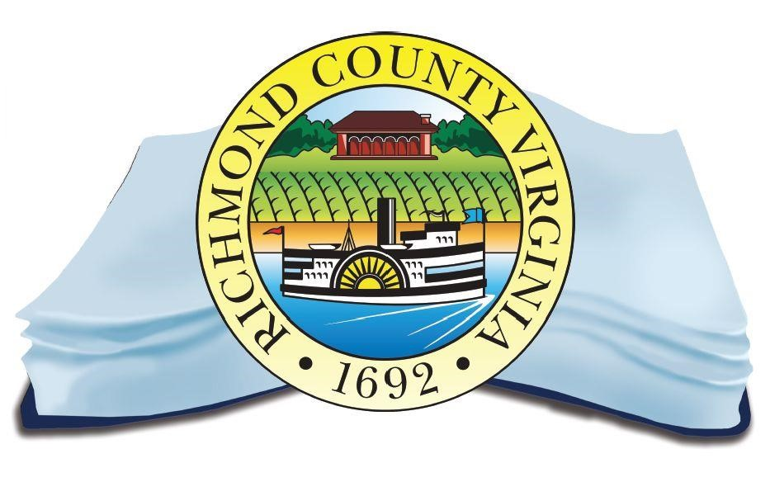

MISSION STATEMENT

The Richmond County Public Library partners with Rappahannock Community College to provide resources to serve the informational, educational, and cultural interests for residents of all ages in order to promote lifelong learning.

HISTORY OF RICHMOND COUNTY PUBLIC LIBRARY

The roots of a public library in Richmond County date back to the early part of the Twentieth
Century. In 1973 the doors of the present facility were opened to the public with the opening of Rappahannock Community College in Warsaw. In 1993, a Memorandum of Understanding was written in a combined effort between RCC and the RC Board of Supervisors and the RCPL was formed. The memorandum of understanding between RCC and RC Board of Supervisors established the operation of the joint library. The shared use of the physical space and library staff by Rappahannock Community College and Richmond County Public Library was the first such joint venture in the Commonwealth of Virginia. The memorandum of agreement was reviewed and updated in 1998. As of 2020, the college and the public library continue the collaboration to provide optimal resources and service to all patrons of the Richmond County Public Library as well as the service area of the college.

The Richmond County Board of Supervisors has appointed a Library Board of Trustees which meets with library staff on a regular basis. The Trustees represent the county constituents and serve as a liaison between the county and the library. The Library Board works with library staff in developing and establishing goals for the County Public Library. Warsaw Town Council plays no formal role in the library’s governance but has generously donated funding to the library every year in recent memory upon request.

The Friends of the Library was established when the Warsaw Campus of Rappahannock Community College opened in 1973. The many activities of The Friends include fundraisers, cultural events, a newsletter, membership directory and volunteer work to support and enrich the library. The Richmond County Public Library and its board recognize the Friends of the Library as an essential component of the library’s success. The Friends represent a segment of the community and their recommendations for improvement of the library are important and welcomed.

DESCRIPTION OF THE SERVICE AREA
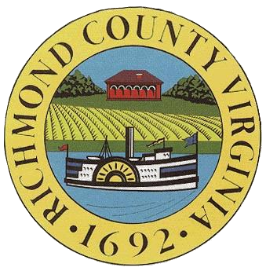
The library is in Warsaw, the county seat of Richmond County, on the campus of
Rappahannock Community College. The Richmond County Public Library is co-located with the Rappahannock Community College Library and shares the same resources. Richmond County cherishes and promotes its rural and agricultural environment. The history and natural resources in the area are highly valued and residents of the County are committed to the preservation and stewardship of these rich treasures. Richmond County enjoys a long history since its founding in 1692. Today, the area is comprised of farmers, working professionals, business owners, civil servants, commuters, and retirees. The library’s central location makes it accessible to all residents of the greater service area. While the Rappahannock Community College (RCC) Library serves both students and community members throughout its entire service region, the Richmond County Public Library mission focuses its services and outreach efforts on Richmond County and the town of Warsaw.

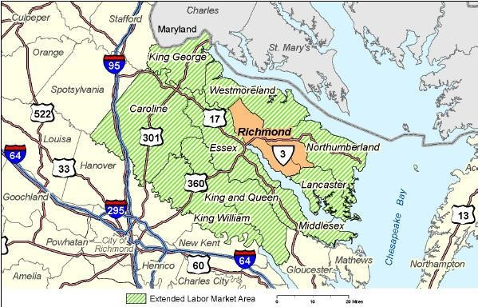

Richmond County’s U.S. Census Bureau 2021 Population Estimates indicate the population is estimated at 9,017, a decline of approximately 2.5% since 2010. Demographic data from 2021 indicate approximately 66% of the population identify as White, 30% as Black or African American, and 7.5% of any race also identify as Hispanic or Latino. The per capita income is $24,400 and the median household income is $58,298. The 2021 Census Bureau estimates that 21% of the population is 65 years and over. < http://www.census.gov/quickfacts/table/AGE775214/51159 >

Richmond County Public School System < https://www.richmond-county.k12.va.us/ > includes Richmond County Elementary/Middle School, Rappahannock High School, Mackey-Thompson Learning Center, and Northern Neck Technical Center (part of the Governor’s STEM Academy for Agriculture and Maritime Studies). Per pupil expenditure for FY 22 is $13,541. < https://www.richmond-county.k12.va.us/Content2/averageperpupilcost > Rappahannock Community College is also an important part of the educational environment within the county and enjoys many partnerships in the community in addition to the public library.

Richmond County has a county administrator and five-member board of supervisors. The board members are elected from five distinct districts from within the county.

CURRENT STATUS AND ASSESSMENT OF COMMUNITY NEEDS

Richmond County Public Library has enjoyed the present partnership with Rappahannock Community College since 1993. This collaboration provides many advantages, including the following:

- Staffing and physical space provided by the college.
- Building and grounds maintenance provided by the college.
- Access to college library collections.
- Established library services and support mechanisms through the Virginia Community College System (VCCS) such as the online catalog and interlibrary loan.
- Increased technological capabilities.
- Friends of the Library support.

GOALS AND OBJECTIVES

Goal I - Contractual Agreement with Rappahannock Community College

Objective A: The Library Board shall review the Memorandum of Understanding on an annual basis by March 1st of each year. If adjustments are suggested, submission to the Richmond County Board of Supervisors and the college should be made at least 60 days prior to the end of the fiscal year (April 30).

Goal II - Personnel

Objective A: Maintain the current contractual partnership with Rappahannock
Community College in order to provide excellent customer service to all members of the community.

Objective B: Continue to assess staffing levels and identify opportunities to diversify to maintain professional and effective service to the community.

Objective C: Develop and provide training opportunities to keep staff abreast of resources, technology, and services.

Objective D: Identify volunteer opportunities as appropriate for the needs of the library.

Objective E: Identify sources of funding for additional library outreach staff or to increase such positions to full-time status

Goal III – Assessment and Evaluation

Objective A: Prepare and report patron count and circulation statistics on an annual basis.

Objective B: Prepare Bibliostat report for the Library of Virginia as required for state aid.

Objective C: Develop and administer user surveys to be administered biennially.

Goal IV: Programming

Objective A: Young Children

- Continue and expand story times to include Spanish language and off-site.
- Continue to develop and grow the Summer Reading Program to reach teenagers and adults, as well as elementary and middle school children. Use online programming and book resources , such as Hoopla. Partner with schools in promotion and execution of summer programs.
- Explore and identify new programming opportunities, offering at least two new programs a year
- Offer programs to expecting parents to encourage emergent literacy

Objective B: Young Adults
- Explore and identify new programming opportunities, offering at least two programs a year focused on age groups 11-17

Objective C: Seniors
- Explore and identify new programming opportunities, offering at least one program a year focused on age groups 55 and up.

Objective D: Correctional Facilities and Other Outreach
- Continue the establishment of a lending program with Haynesville Correctional Center and Northern Neck Regional Jail

Objective E: Partnering with RCC
- Identify opportunities to offer educational programming
- Identify potential adult education opportunities

Objective F: Partnering with the Community
- Police, Fire and Safety
- Identify local businesses for programming partnerships

Goal V: Collection

Objective A: Serve the informational needs of the community through diverse collections and information resources

Objective B: House and provide access to a quality general collection of books and other materials that reflect and respond to the leisure interests and reading needs of community residents.

Objective C: Special Focus on the juvenile and young adult collection to add more nonfiction material and partner with local schools to bolster educational needs.

Objective D: Develop a Collection Development Policy for RCPL.

Goal VI: Publicity and Marketing

Objective A: Improve and update the Richmond County Public Library Website, adding resources there for all user groups for lifelong learning.

Objective B: Include a calendar of events on the Public Library Website

Objective C: Utilize a variety of publicity and marketing tools such as the web page, flyers, calendars, newspaper articles and photographs to promote and share information about services, resources and events. Also use newspaper advertisements, posters, radio advertising and mass mailing to local households.
Objective D: Develop and deliver messages through a variety of methods including social media to effectively spur increased support of the library.
Objective E: Develop effective methods and approaches that demonstrate the library’s value to local decision makers and community members, such as library assessments and user surveys.

Goal VII: Accessibility

Objective A: Investigate options for parking and delivery to cars for those users with disabilities who cannot easily walk from RCC’s public parking areas.

Objective B: Collaborate with College to develop improved directional signage.

Objective C: Provide strong Wi-Fi signal to outdoor areas to provide free community access to the Internet

OBJECTIVE D: Provide book and DVD pickup service for those who cannot easily get inside the library.

Goal VIII: Advocacy and Fund Raising
Objective A: Continue seeking funding from existing governmental sources and pursue other governmental sources that may be available by building strategic partnerships with local groups and leaders that can support the library.
Objective B: Participate in seeking gifts, donations, materials, memorials, etc. from public and private sources.

Objective C: Assist and participate in the library staff’s efforts in identifying grants for the library.

Goal IX: Annual Review of the Long-Range Plan

Objective A: Review plan at the end of each Fiscal Year to identify updates to be shared with the Library of Virginia by August 1.

Submitted to The Library of Virginia – June 2024

